Getting ready to go

Workbook 3

My daily life

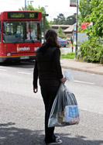

English to help you get ready if you are going to live the UK after release.

Getting Ready to Go – Workbook 3: My daily life

Contents page

How to use the workbook 3

Task 1 Writing letters 4

Task 2 Planning your time 9

Task 3 Keeping appointments 11

Task 4 Telling the time 15

End of unit check 18

Answers 19

How to use the workbook

This workbook has activities on;

- reading
- vocabulary
- grammar
- writing

You need a pen or pencil.

Read the instructions for each task carefully.

Do the activities then check your answer using the ANSWERS pages at the back of the workbook.

Workbook 3 – Daily life
Learning goals
By the end of this unit you will be able to:
- write personal messages and letters
- make appointments outside prison
- read and tell the time
- use a diary and plan your time outside

Task 1

Soon you will be leaving prison. It is time to plan for you time outside.
It is time to prepare get back in touch with friends and family.

You can phone family and friends from your wing, but it is very nice to write and get write letters.

Friends and family can keep your letters and read them over again. They like to hear your news. Some will meet you when you come out of prison.

Here is an example.
HMP Woodall
LB32 4GG
Dear Marta,
How are you? I hope you are well and the kids are being good. I’m well. I go to the gym here and I’m getting very fit. I like playing volleyball on Wednesday afternoons.

I come home in three weeks. I’m looking forward to seeing you. I hope we can go shopping together. I need some new clothes. We can go to the cinema. And I need to make an appointment at the hairdressers.

I’ll phone you when I get home.
Love from
Rita

(1) Why not try a letter of your own here?

- Start: Hi (write the person’s name)

- Ask them: how are you?
- What have you been doing?

- Tell them: what you have been doing? What have you see on TV? Have you been to the gym or the library? What have you been learning?

- Finish: That’s all for now.
- Love from,
- See you soon.

- Sign your name



Use some of the words in the grid to help you. You can also use a dictionary to help you find more words.

always ...... | beautiful | caring
delightful | easy | fun
gorgeous | happy | intelligent
jolly | kind | lovely
magic | nice | cool
perfect | quiet | relaxed
super | trusting | understanding
very..... | wonderful | x ( use xxx as kisses)
young (at heart) | zany

You can write special messages for family and friends using their name. Write their name downwards on the page like this.

A – always laughs
M – much loved
I – in my thoughts
N – not long until I come home

Think of something special about that person using each letter of the name. Here is another example. You can use a dictionary to help you.

H – happy
A – always laughs
M – mum loves you
I – I’ll soon be home
L – love you
A – always thinking of you

Task 2 Planning your time
(1) When you leave prison you need to plan your time. This can be difficult at first. In prison you don’t need to plan your day.
- What do you do each day in prison?
- What comes first?

Write what you do each day. Here are some pictures to help you

 |  | 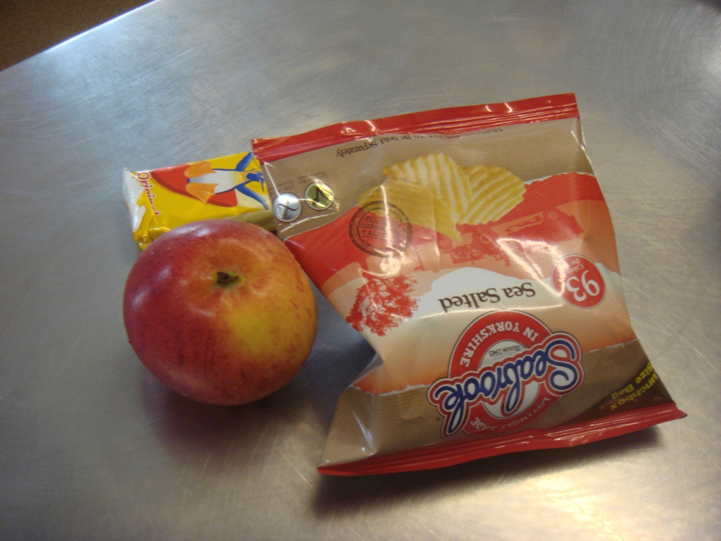 | 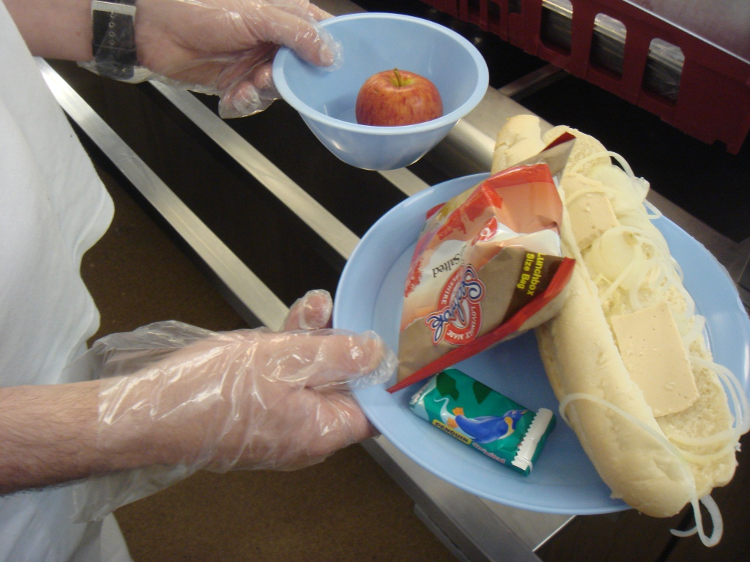
 | 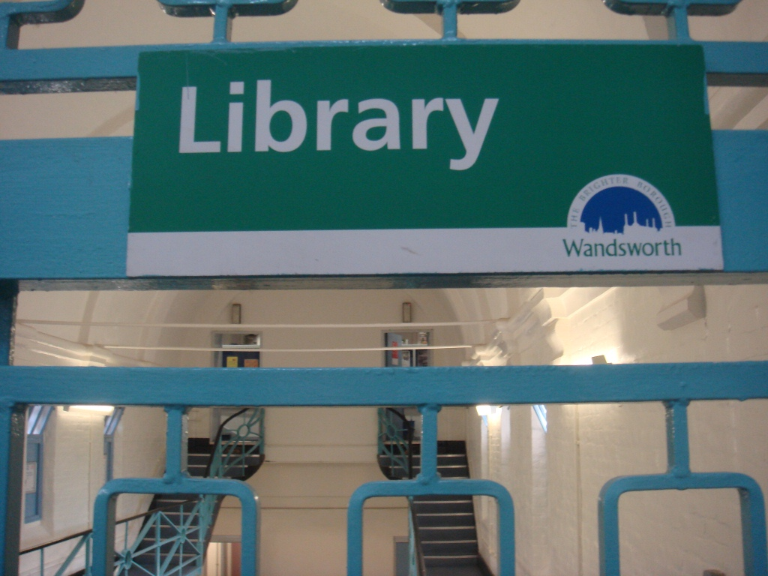 |  | 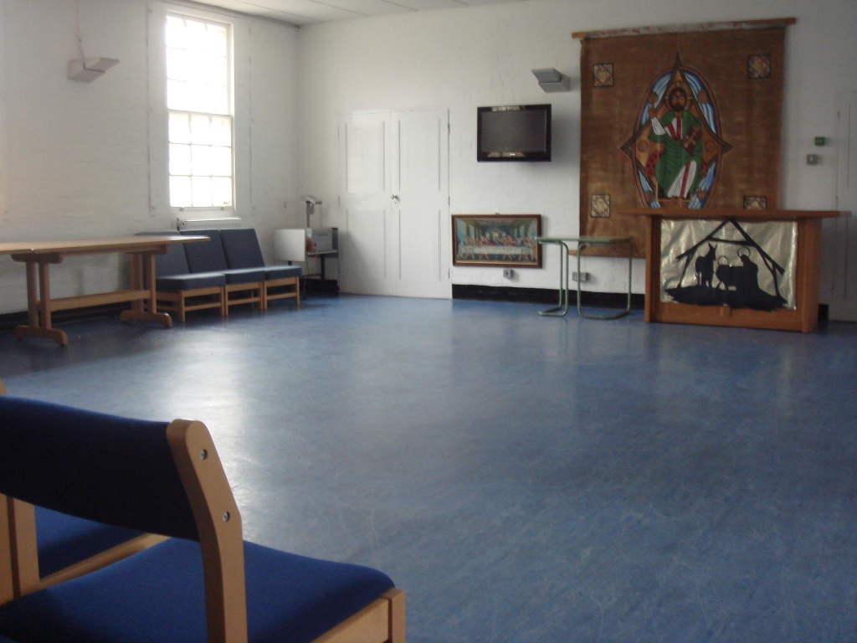

Morning _____________________________________________________
_____________________________________________________
_____________________________________________________

Afternoon _____________________________________________________
_____________________________________________________
_____________________________________________________
Evening _____________________________________________________
_____________________________________________________
_____________________________________________________
Night _____________________________________________________
(2) Coming out of prison can be difficult as you need to plan your own day
- How do you plan your day?
- What comes first?
- Look at the pictures and write in what you will do.
What other things will you do? Add some more.
 |  |  | 
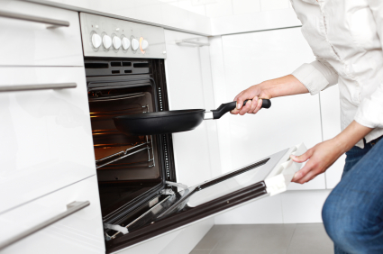 |  |  | 

(3) What can you do each day?
Check your spelling for days of the week. Fill in the letter gaps.
W_dne_day
Mo_ _ay
S_nda_
Tue_d_ _
Sa_u_d_y
T_urs_ _y
Write the days in the order they come starting with Sunday
Sunday

(4) Before and after
Tuesday comes before Wednesday (Tuesday then Wednesday).

Saturday comes after Friday (Friday then Saturday).

- Which day comes before Monday?
- Which day comes after Thursday?
- Which day comes before Wednesday?
- Which day comes after Friday?
- Which day comes before Sunday?
- Which day comes after Tuesday?
- 2 days before Sunday?
- Which 2 days make the weekend?
Check your answers at the back of the book.
Task 3 Keeping appointments
It is very important to keep appointments. You might need to meet your probation officer each week. If you miss that appointment you might find yourself back in prison.
Hospital appointment

Day: Wednesday
Date: 26 September 2015
Time 3.00pm
You may need to see:
- a doctor
- your probation officer
- benefits adviser
- job centre adviser

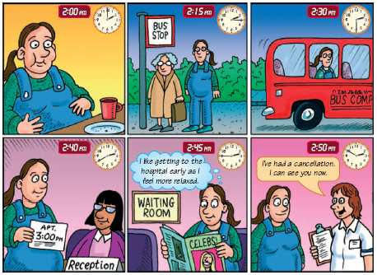
Have a look at the story below, about a hospital appointment
‘Family health’ Module 1 Getting in touch © Learning and Skills Improvement Service
http://rwp.excellencegateway.org.uk/resource/Family+health+Module+1%3A++Getting+in+touch/pdf/1/
(1) Answer the questions about the story and pictures on the page before.

- What time does she get to the bus stop? ..............................................

- What time does she get the bus?...........................................................

- Is she early or late for the appointment?................................................

- What time does the doctor see her?......................................................

(2) Making appointments
You have appointments to keep. Write them in the table below.
- You are going:
  - to the cinema at 8pm on Friday.
  - to the probation office on Wednesday morning.
  - shopping on Tuesday afternoon.
  - to see a teacher at school on Thursday afternoon after school.
- Your friend is coming to see you on Monday morning at 11am.
- You have to go to the housing office on Thursday morning at 10am

 | morning | afternoon | evening
Monday

Tuesday

Wednesday

Thursday

Friday

Saturday

Sunday

- Later your friend calls you to say she can’t see you on Monday morning. Cancel the appointment in your diary.
Check your answers at the back of the book.
(3) Keeping appointments

early on time late

Shami’s appointment is at 10am. She arrives at 9:30. She is early.

If she arrives at 10 am she is on time. If she arrives at 11 am she is late.

When you get out of prison you must try to be on time for your appointments.

Read the next section and never be late again! Match why the person was late with what they need to do to be on time. Number 1 is a correct example.

Why you are late? | How to be on time
1. I slept in (in bed too long) d | a. get up early to walk the dog
2. I stopped to chat to a neighbour | b. speak to your friend when you have more time
3. The bus was late | c. check where to go the day before
4. I wasn’t sure where to go | d. make sure your alarm clock works
5. I got the wrong bus | e. say you are sorry, but you are busy and call on your neighbour this evening
6. I had to walk the dog | f. get to the bus stop early
7. I missed the bus | g. take an earlier bus to make sure you’re on time
8. I phoned my friend for a chat | h. check the bus map to see where you are going

Check your answers at the back of the book.
(4) Write the appointments from under the table in your diary.

 | morning | afternoon
Monday

Tuesday

Wednesday

Thursday

Friday

Saturday

Sunday

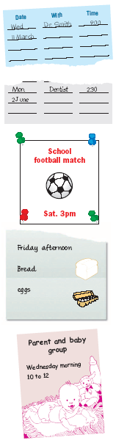
From ‘Family health’ Module 1 Getting in touch © Learning and Skills Improvement Service
http://rwp.excellencegateway.org.uk/resource/Family+health+Module+1%3A++Getting+in+touch/pdf/1/

Think of things you will do when you get out and write some of you own ideas in.
Task 4 Telling the time
(1) Can you match the clock times to the appointments?
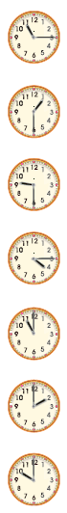
Probation Services
You have an appointment with Steve Harper at 1.30 pm
Grange Street Office



Hospital appointment
Day: Monday
Date: 15th September
Time: 9.30pm

Greenside Dental Care
2 pm
Friday 26th September
Please be on time

Curl up and Dye Hairdressers
Wednesday 3rd September
2 o’clock

Jobcentre Plus
Tuesday every 2 weeks
11.15 am

From ‘Family health’ Module 1 Getting in touch © Learning and Skills Improvement Service
http://rwp.excellencegateway.org.uk/resource/Family+health+Module+1%3A++Getting+in+touch/pdf/1/

Check your answers at the back of the book.
(2) Using a calendar. Write the appointments below in the calendar.
September
Sunday | Monday | Tuesday | Wednesday | Thursday | Friday | Saturday
 | 1 | 2 | 3 | 4 | 5 | 6
7 | 8 | 9 | 10 | 11 | 12 | 13
14 | 15 | 16 | 17 | 18 | 19 | 20
21 | 22 | 23 | 24 | 25 | 26 | 27
28 | 29 | 30
Greenside Dental Care
Friday 26th September
Please be on time
Probation Services
You have an appointment with Steve Harper at 10am 17.09.15
Grange Street Office
Curl up and Dye Hairdressers
Wednesday 3rd September
4.30pm
Hospital appointment
Day: Monday
Date: 15th September
Time: 3pm

(3) Making appointments at the health centre
Stockwell Health Centre opening times
 | Morning | Lunch closed | Afternoon
Monday | 8.30 am– 1pm | 1pm – 2pm | 2pm – 6.30pm
Tuesday | 10am – 1pm | 1pm – 2pm | 2pm – 8.30pm
Wednesday | 10am – 1pm | 1pm – 2pm | 2pm – 6.30pm
Thursday | 9.30 am – 1pm | 1pm – 2pm | 2pm – 8.30pm
Friday | 8.30 am– 1pm | 1pm – 2pm | 2pm – 6.30pm
Saturday | 8.30 am– 1pm | 1pm – 2pm | 2pm – 6.30pm
Sunday | CLOSED ALL DAY | CLOSED ALL DAY | CLOSED ALL DAY
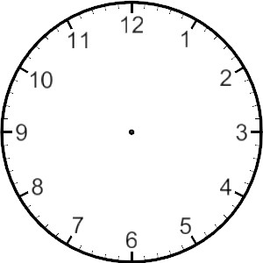
- The health centre opens at 10am on Tuesday. Draw the time on the clock face.

- The health centre is open after 8pm on Tuesday. Tick the right answer. True/ false?
- The health centre closes for lunch every day. Tick the right answer.
True/ false?
- The health centre opens at 8.30 am on Thursdays. Tick the right answer.
True/ false?
- The health centre is open at 1.30 pm on Friday. Tick the right answer.
True/ false?
- You can make an appointment on Sundays. Tick the right answer.
True/ false?
- The health centre closes at 8.30 on two days. Write the two days below.
(4) Bus timetables: draw the times in the clocks then answer the questions under the table.
Bus to | Arrival time | Can you draw the correct time on the clock face? | Leaves at | Can you draw the correct time on the clock face?
Greenfield Avenue | 10:30 |  | 10:40
Stonegate Park | 12:15 |  | 12:25

- The bus arrives at Greenfield Avenue at half past eleven. Tick the right answer. True/ false?
- The bus leaves Greenfield Avenue at twenty to eleven. Tick the right answer. True/ false?
- The bus arrives at Stonegate Park at quarter past 12. Tick the right answer. True/ false?
- The bus leaves Stonegate Park at twenty five to twelve. Tick the right answer. True/ false?
- Write half past ten like on a digital watch or clock.
:

Check your answers at the back of the book.

End of unit check

Now you have finished this unit, how do you feel? Tick (✓) the box that is true for you.

 | Yes | A little | No
I feel my reading is better.
I can write personal messages and letters
I know how to make appointments outside prison
I know lots of new words.
I can read and tell the time
I can use a diary and plan my time outside
Answers: Task 2 (1)
Wednesday
Monday
Sunday
Tuesday
Saturday
Thursday

Write the days in the order they come starting with Sunday
Sunday Monday Tuesday Wednesday Thursday Friday Saturday

(2) Before and after

- Which day comes before Monday? Sunday

- Which day comes after Thursday? Friday

- Which day comes before Wednesday? Tuesday

- Which day comes after Friday? Saturday

- Which day comes before Sunday? Saturday

- Which day comes after Tuesday? Wednesday

- 2 days before Sunday? Friday

- Which 2 days make the weekend? Saturday and Sunday

Task 3 (1)
- What time does she get to the bus stop? 2:15.
- What time does she get the bus? 2:30
- Is she early or late for the appointment? early
- What time does the doctor see her? 2:50

(2) You have appointments to keep. Put them in the table.
 | morning | afternoon | evening
Monday | 11 am Eva is coming
Tuesday |  | Going shopping
Wednesday | Probation office
Thursday | 10am housing office | Going to see teacher
Friday |  |  | 8pm cinema
Saturday
Sunday

(3) Keeping appointments
Why you are late? | How to be on time
1. I slept in (in bed too long) | d. make sure your alarm clock works
2. I stopped to chat to a neighbour | e. say you are sorry, but you are busy and call on your neighbour this evening
3. The bus was late | g. take an earlier bus to make sure you’re on time
4. I wasn’t sure where to go | c. check where to go the day before
5. I got the wrong bus | h. check the bus map to see where you are going
6. I had to walk the dog | a. get up early to walk the dog
7. I missed the bus | f. get to the bus stop early
8. I phoned my friend for a chat | b. speak to your friend when you have more time
(4)
 | morning | afternoon
Monday |  | 2.30 pm – dentist
Tuesday

Wednesday | 9 am – Dr Smith
Thursday

Friday |  | Shopping – bread and eggs
Saturday |  | 3 pm – football match at school
Sunday

Task 4 (1)Telling the time – can you match the clock times to the appointments?
Greenside Dental Care
2 pm
Friday 26th September
Please be on time
Probation Services
You have an appointment with Steve Harper at 1.30 pm
Grange Street Office

Jobcentre Plus
Tuesday every 2 weeks
11.15 am

Curl up and Dye Hairdressers
Wednesday 3rd September
4.15 pm

(2)The health centre opens at 10am on Tuesday. Draw the time on the clock face.
1.

- The health centre is open after 8pm on Tuesday. True
- The health centre closes for lunch every day. True
- The health centre opens at 8.30 am on Thursdays. False
- The health centre is open at 1.30 pm on Friday. False
- You can make an appointment on Sundays. False
- The health centre closes at 8.30 on two days. Write the two days below
Tuesday | Thursday

(3) Bus timetables Have a look at the timetable below and answer the questions. Check your answers at the back of the book.
Bus to | Arrival time | Can you draw the correct time on the clock face? | Leaves at  ( departs at) | Can you draw the correct time on the clock face?
Greenfield Avenue | 10:30 |  | 10:40
Stonegate Park | 12:15 |  | 12:25

- The bus arrives at Greenfield Avenue at half past eleven. False
- The bus leaves Greenfield Avenue at twenty to eleven. True
- The bus arrives at Stonegate Park at quarter past 12. True
- The bus leaves Stonegate Park at twenty five to twelve. False
- Write half past ten as it would be on a digital watch
10:30

